

**MINI-PROJECT SYNOPSIS**

TEAM MEMBERS: -

* PAVAN T L (1SI17TE020)
* SUMANT KUMAR (1SI17TE035)
* PRAMODH H R (1SI17TE021)
* ANUSHANT BHUSHAN (1SI17TE004)

Signature of guide

**TITLE:-**‘**EYE FOR BLIND’**

**OBJECTIVE :-**

We have seen blind people facing many problems in our society. So, we have come up with some solution for some problems they facing. As they are blind, they are not able to read the medicine name and they always depends on other person for help. Some people take advantage of their disability and cheat them by taking extra money or by giving less money. And by this project we are making them independent in terms of medical benefits.

**BLOCK DIAGRAM: -**

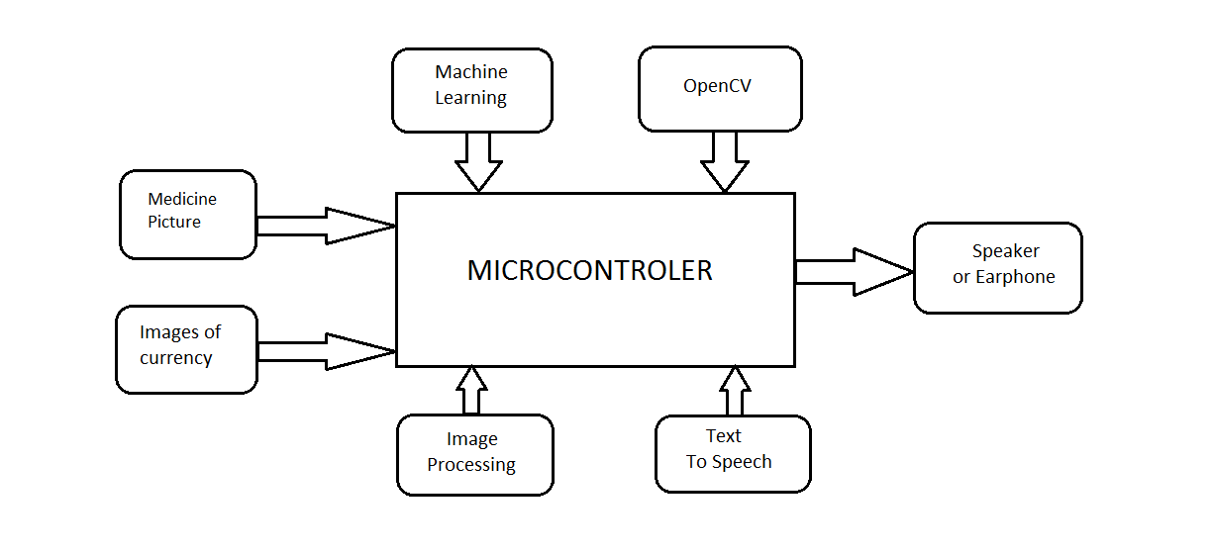

**METHODOLOGY: -**

To overcome the problem of blind person we have come up with an innovative idea, where we are making use of machine learning, image processing, OpenCV, text to speech and OCR technologies. To make their life comfortable.

In this project we are using a camera for getting the input, where the inputs are pictures of medicine and of currency. These images can be manipulated using image processing and OpenCV. Once the processed imaged is obtained then it is cropped and thresholding is done, In the next stage we will extract the name of medicine, then we will convert that text into speech using text to speech technology.

Similarly, we will also take picture of currency and then by using image processing and machine learning we will compare the picture with predefined database of the currency that we have already prepared. The next process will be to covert the value of currency into text and then the text is converted into speech using text to speech technology

**Technology Stack:**

•**Image Processing:** To extract necessary information

•**OpenCV:** To threshold image, colour shifting, scanning and cropping, setting grey level, and to extract contours

•**Python 3:** To set up environment and interact with devices

•**OCR (Optical Character Recognition):** Mechanical or electronic conversion of images of typed, handwritten or printed text into machine-encoded text, whether from a scanned document or a photo of a document

•**Machine Learning:** Handwritten data is trained in a classifier to process manual marks awarded

**TIME PLAN:-**

* In next 30 days we will learn about the used technology.
* After that we start implementing step by step.
* By the end of the semester we will try to complete 30% of our project.
* Up to March we will complete our project as a working model.

**OUTCOMES: -**

1.Blind persons are able to identify the name of the medicine by themselves.

2.Blind people will have economical benefits.